Ta Quang Tung - 104222196

D Custom Program Instructions

Program description

Descend Below (Lite) is a roguelike video game where the player battle enemies to progress through endless floors. Each floor is made up of rooms, which contain enemies and exits that lead to other rooms. One room on each floor contains a staircase that can be clicked on to enter a new floor.

The player attack enemies by left clicking. Enemies attack the player by firing projectiles at them. The game ends when the player’s health reaches 0, after which the game can be reset.

Controls

W/A/S/D to move.

Left click to attack.

Right click to interact with objects like staircases. Note that you must get close to these objects to interact with them. There should be a blinking indicator when you are close enough.

ESC to pause/unpause the game.

Gameplay screenshot

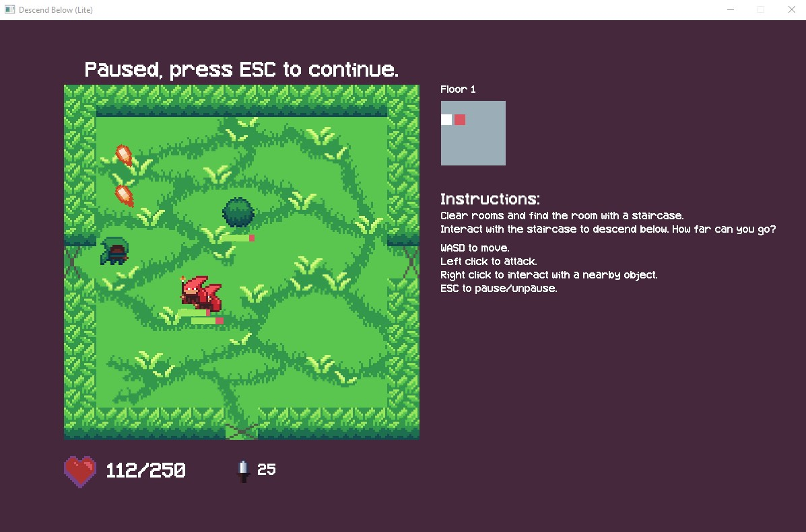

*Gameplay of Descend Below (Lite).*